**ACTIVE DIRECTORY INSTALLATION**

Click the server manager symbol on task bar of Windows Operating System (Desktop Mode)



Click the add roles and features

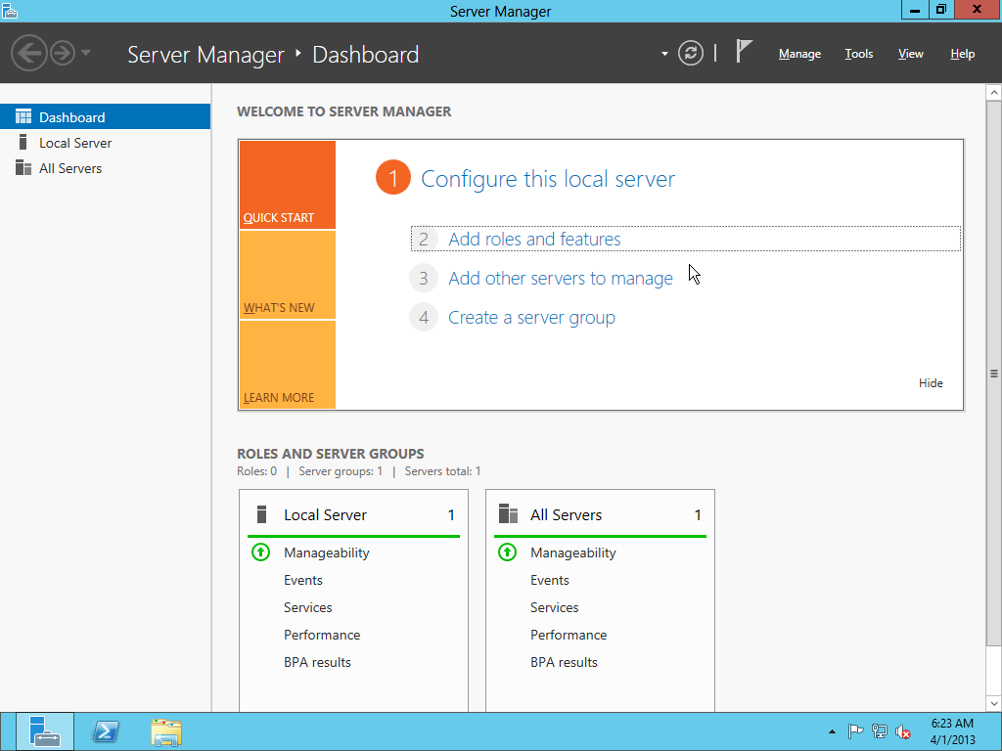

Click the Next button

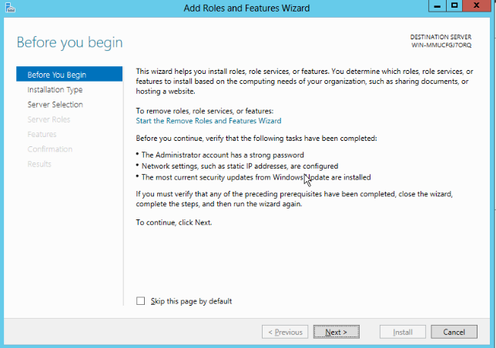

Click the Next button

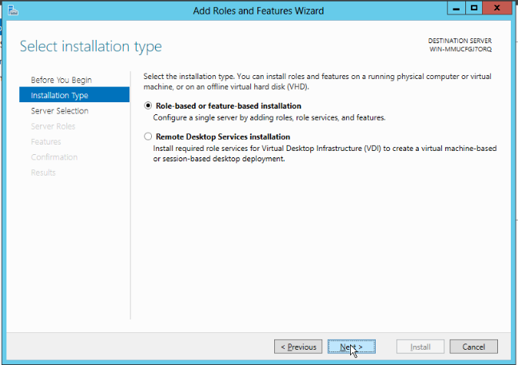

Click the Next button

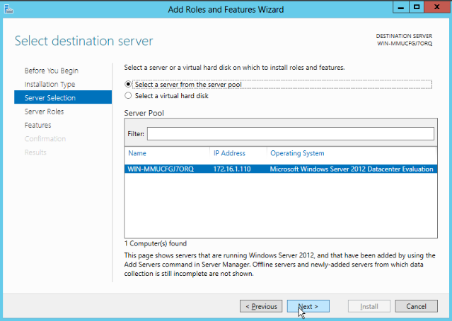

Select the **Active Directory Domain Services** and click Next

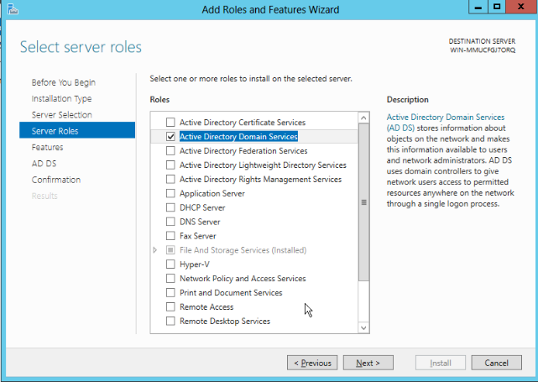

Click Next

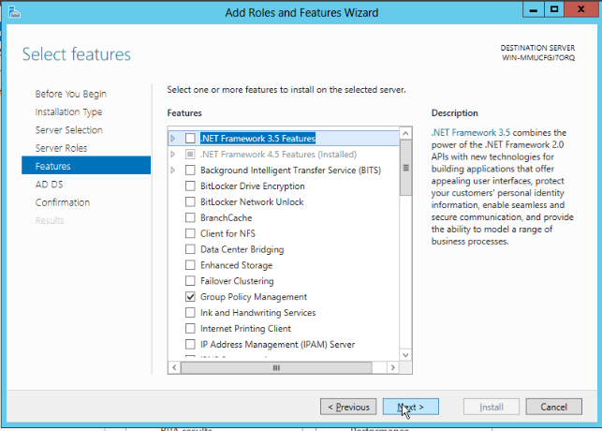

Click the Next

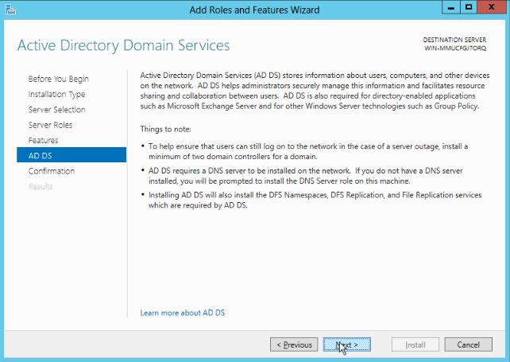

Click Yes

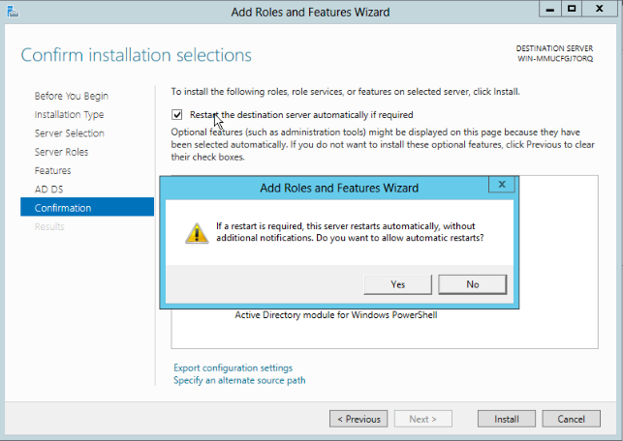

Select the **restart the destination server automatically if required** and click the **install option**

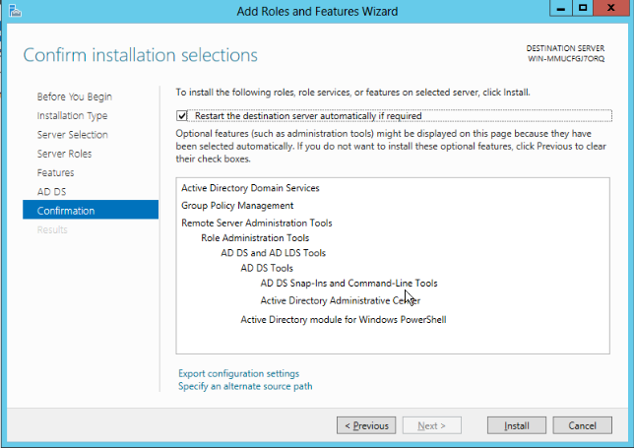

Now click **promote this server to a domain controller**

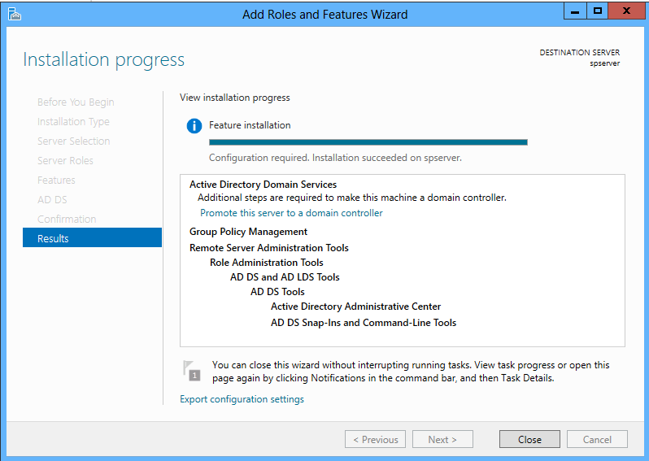

Select the **Add a new forest** and enter the **domain name** and click Next

Note: **Root Domain Name -** Instead of spapp.com as shown in figure, it can be SPDemoDomain.com

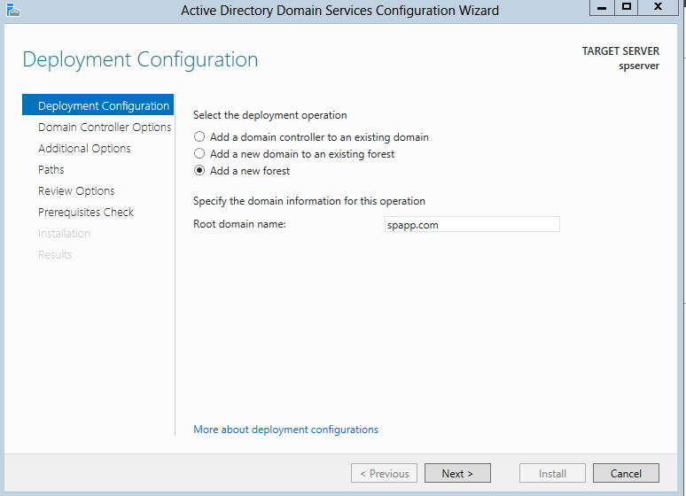

Now enter the administrator password and click Next

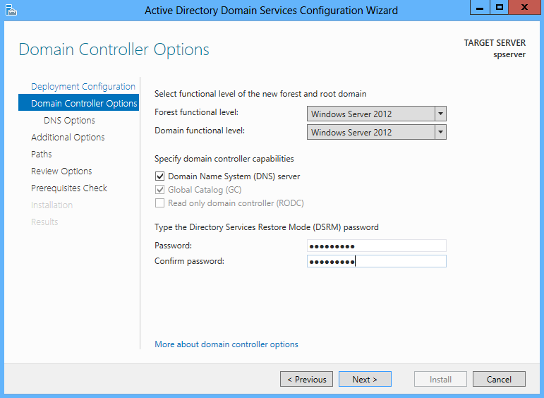

Un-check the create DNS delegation and click Next

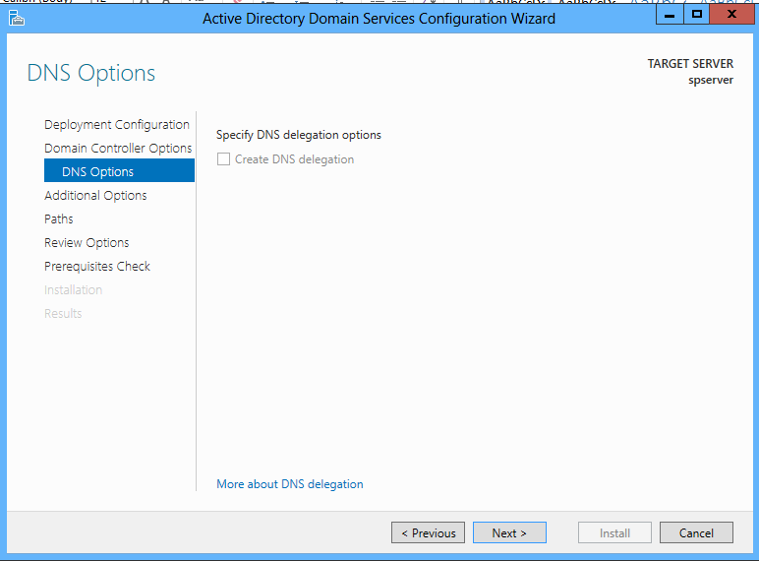

Let the default option be as it is (NetBIOS name: **SPDemoDomain**) 🡪 Click Next

Note: Instead of SPAPPS as shown in figure, it can be SPDemoServer(Machine Name)

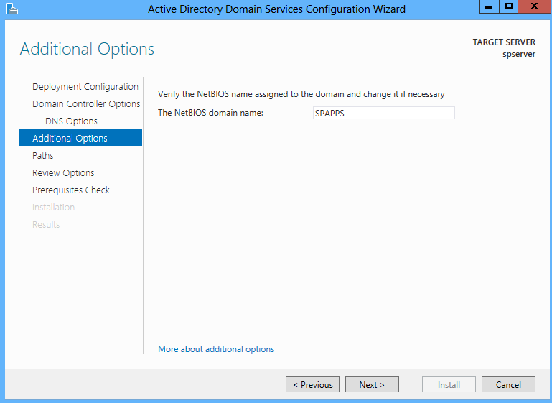

Click Next

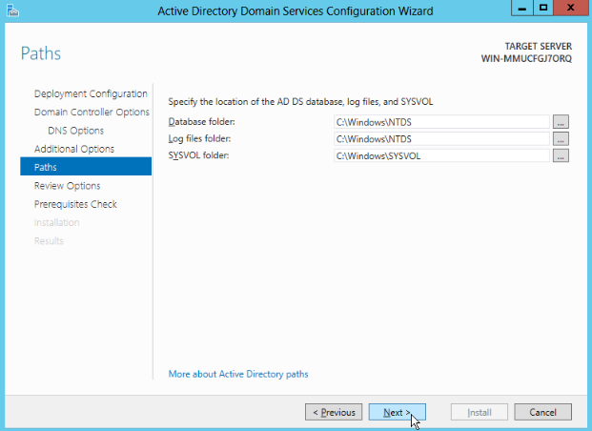

Click Next

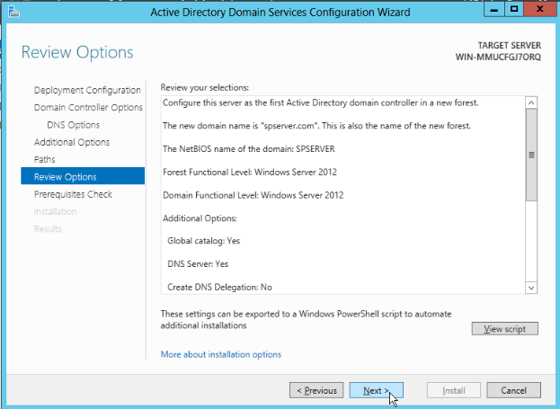

Ignore the Warnings and Click the install option

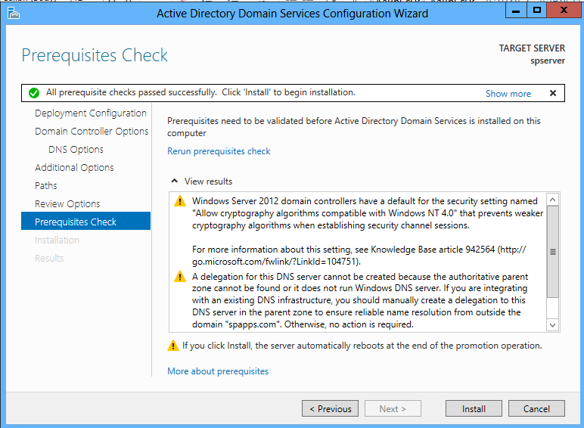

Click the close option it will reboot the system.

